Install & Using WkhtmlPdf (NReco.PdfGenerator) – Generate Html ke Pdf

Langkah-langkah menginstall WkhtmlPdf (NReco.PdfGenerator) seperti gambar di bawah ini:
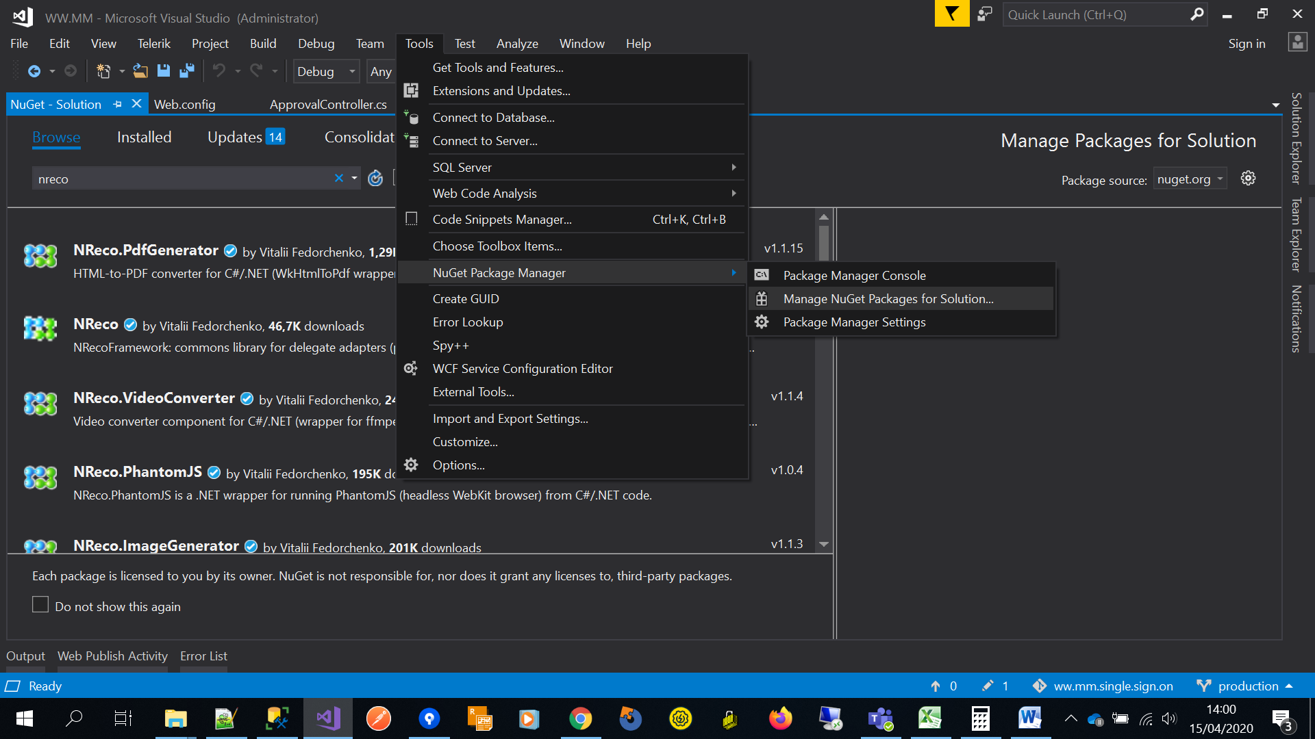
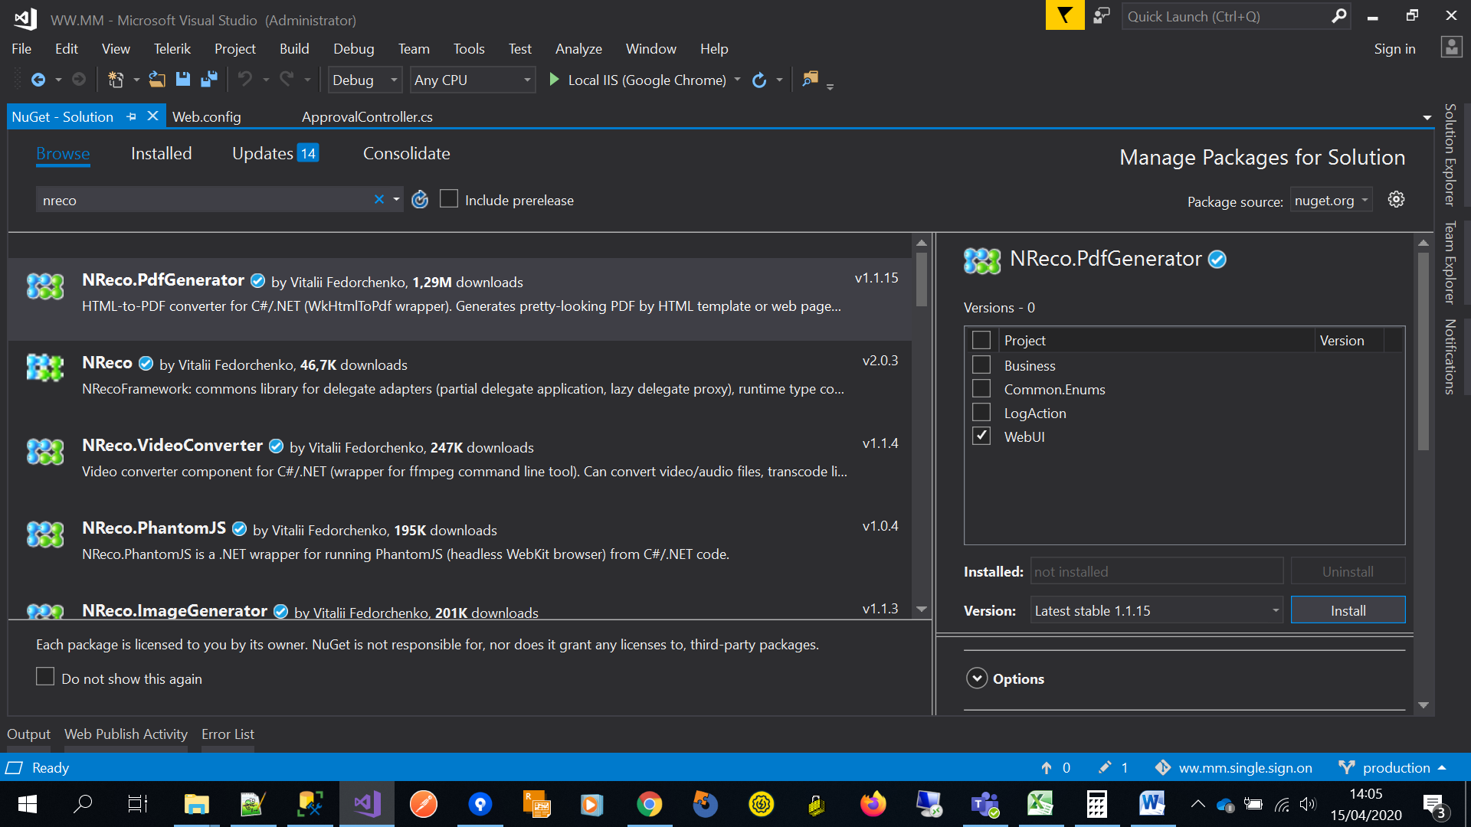

- Klik menu Tools (Visual Studio)
- Klik menu NuGet Package Manager Manage NuGet Packages for Solution
- Pada tab Browse, ketik nreco lalu cari.
- Pilih NReco.PdfGenerator
- Ceklis diproject mana NReco akan diinstall
- Klik install dan tunggu sampai proses installasi selesai.

Cara Menggunakan WkhtmlPdf (NReco.PdfGenerator)
public static bool HtlmToPdf(string fileName, string html, string directory = null)
{
//lib
string message;
byte[] bytes;
HtmlToPdfConverter converter = new HtmlToPdfConverter
{
PdfToolPath = DirectoryUtil.GetPhysicalPath(WKHTML_DIRECTORY),
Size = PageSize.A4, ////bisa custom
Margins = new PageMargins { Bottom = 5 // bisa custom}
};

//algorithm
try
{

bytes = converter.GeneratePdf(html);
FileUtil.Save(fileName, bytes, directory);
}
catch (Exception ex)
{
message = ex.Message;
return false;
}

return true;
}

